Sloppy Joe Tater Tot Casserole
Serves: 8

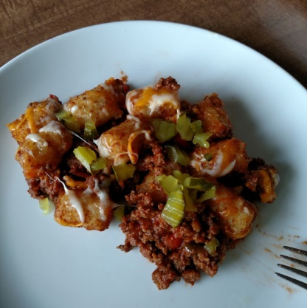
Ingredients:

- 1 lb. lean ground beef
- 1 cup chopped onion
- 1 can (15 oz.) Sloppy Joe Mix OR the following :
  - 1can (15 oz.) tomato sauce
  - 2 Tbsp. packed brown sugar
  - 1 Tbsp. Worcestershire Sauce
  - 1 Tbsp. yellow mustard
  - 1/2 tsp salt
- 1 bag (32 oz.) frozen tater tots
- 2 cup shredded cheddar cheese (8 oz.)
- 1/4 cup chopped dill pickles

Directions:

1.Heat oven to 350 degrees F. Spray 13x9" (3 qt.) baking dish with cooking spray.

2. Brown hamburger with onion. Drain grease. Stir in tomato sauce, brown sugar, Worcestershire Sauce, yellow mustard, and salt (or can of sloppy joe mix). Cook 2-3 minutes stirring frequently until bubbly.

3. Line bottom of baking dish with half of bag of tater tots. Pour beef mixture on top of tots. Add 1 cup of cheese over the beef mixture. Add remaining tots and top off with last cup of cheese. Bake 45 minutes or until bubbly and tater tots are slightly browned. Top with chopped dill pickles.

**Note**: I don't do all of the layers. I put the sloppy joe/meat mixture in the bottom of the baking dish, add a layer of tater tots, and bake. After the casserole is baked I add the cheese and let it melt for 5 minutes, add chopped pickles, and serve.

